

**PROJECT**

**“School Data Management App”**

**Faculty:**

Dimas Yudha Prawira., S.Kom, M.Kom

**Written By:**

1. Dhayu Wiragusti (2220010109)

2. Najwa Syifa (2220010253)

**Class:**

**4 ISA 2**

**CEP CCIT**

**FAKULTAS TEKNIK UNIVERSITAS INDONESIA**

**2024**

**PROJECT ON**

**School Data Management App**

Page 3

**Developed by**

1. **Dhayu Wiragusti**
2. **Najwa Syifa**

**School Data Management App**

**Developed by**

Batch Code : 4ISA2

Start Date : 29 March 2024

End Date : 24 April 2024

Name of Faculty : Dimas Yudha Prawira., S.Kom, M.Kom

Names of Developer:

1. Dhayu Wiragusti
2. Najwa Syifa

Date of Submission: 24 April 2024

**CERTIFICATE**

This is to certify that this report titled “School Data Management App” embodies the original work done by Dhayu Wiragusti and Najwa Syifa. Project in partial fulfillment of their course requirement at NIIT.

Coordinator:

Dimas Yudha Prawira., S.Kom, M.Kom

**ACKNOWLEDGEMENT**

The author would like to express his gratitude to the presence of God Almighty for His mercy and grace, we were able to complete this project assignment, both in the form of a presentation and paper, on time.

The author would also like to thank Mr. Dimas Yudha Prawira., S.Kom, M.Kom, and other lecturers for all their guidance so that we could complete it. Thank you to fellow students who have supported me, and also thank you to fellow workers in the education sector at CCIT-FT UI.

The author submits the project paper entitled "School Data Management App" as a requirement for the Project assignment in 2024.

Finally, the author hopes that this article can be useful for everyone and also increase insight into operating systems. The author realizes that this book is still not perfect. Therefore, the author hopes for constructive suggestions and criticism from readers for the perfection of this paper. Hopefully, this paper can provide many benefits for its readers.

The use of applications is closely related to daily activities. Applications are needed to support various activities such as working, shopping, studying, or others. The application is designed to be able to carry out commands according to user needs. The definition of an application itself is a ready-to-use program created by a user that is intended to perform a specific task.

The School Data Management Application can be an application that helps with administration, managing student data, attendance, schedules, and provides high flexibility and scalability, allowing schools to access data in real-time, integrate systems, and strengthen communication between stakeholders. Modern school applications offer integrated solutions that leverage data intelligence, process automation and digital collaboration to improve the efficiency and quality of education services.

Implementing school data management applications brings various significant benefits, such as; Increasing administrative efficiency through process automation, increasing the accuracy and consistency of school data, strengthening collaboration between teachers, students, parents and other related parties, supporting data-based decision making to improve the quality of learning, and ensuring the security and privacy of student data in accordance with applicable regulations. applies. Although sometimes there are disadvantages such as it takes time and resources to provide training to users to be able to use the application effectively, especially for users who are less experienced with technology, and school applications can make schools more dependent on technology, and technical problems such as network problems or System failure may disrupt operations.

This paper aims to discuss in depth the role and implementation of school applications in the context of modern education. Through analysis of school needs, the benefits of information technology, and case studies of the implementation of school applications, it is hoped that this paper can provide valuable insight for readers regarding the importance of technology in improving the efficiency and quality of education.

**SYSTEM ANALYSIS**

**SOFTWARE**

1. Apache Netbeans



Apache NetBeans provides editors, wizards, and templates to help you create applications in Java, PHP and many other languages. Apache NetBeans can be installed on all operating systems that support Java, Windows, Linux, Mac OSX and BSD. Write Once, Run Anywhere, applies to NetBeans too.

1. XAMPP



XAMPP is free software, which supports many operating systems, is a compilation of several programs. Its function is as a stand-alone server, which consists of the Apache HTTP Server program, MySQL database, and a language translator written in the PHP and Perl programming languages.

1. Pichon



The free graphics are pixel perfect to fit the design and are available in PNG.

**STEP – BY – STEP GUIDE TO CREATING A SCHOOL DATA MANAGEMENT APP**

Steps to create a school application using Apache Netbeans, XAMPP, and Pichon:

1. Prepare the Development Environment: Make sure you have downloaded and installed NetBeans Apache. Also prepare a database that will be used to store school application data.
2. Create a New Project:
3. Open NetBeans Apache and create a new project by selecting "File" -> "New Project".
4. Select the category "Java" and the project type "Java Application" or "Java Web Application", according to your application needs.
5. Give your project a name (for example, "SchoolManagement") and specify a project storage location.
6. User Interface (UI) Design: Add elements such as buttons, input fields, tables and other UI components according to the needs of the school application.
7. Application Functionality Code:
8. Implement school application business logic. For example, data management for students, teachers, lesson schedules, and so on.
9. Use JDBC or Hibernate to interact with the database you set up earlier.
10. Make sure to add features like data validation, user authentication, and session management where necessary.
11. Test the Application: Test the application to ensure all features work well and meet your needs.

**FLOWCHART**

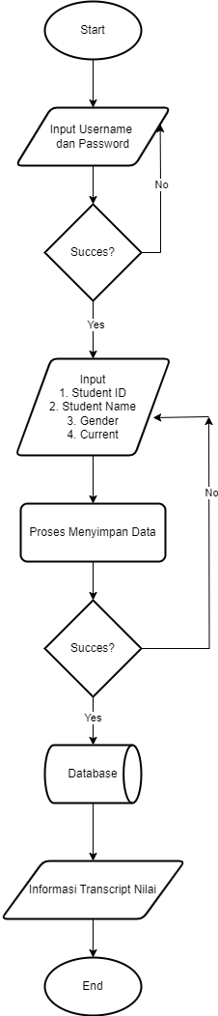

**SOURCE CODE**

/*

* Click nbfs://nbhost/SystemFileSystem/Templates/Licenses/license-default.txt to change this license

* Click nbfs://nbhost/SystemFileSystem/Templates/GUIForms/JFrame.java to edit this template

*/

package schoolmanagement;

import java.sql.*;

import javax.swing.JOptionPane;

import java.sql.*;

import java.sql.Connection;

import java.sql.Statement;

import java.sql.ResultSet;

import javax.swing.JOptionPane;

import practice.connection;

/**

*

* @author najwa

*/

public class home extends javax.swing.JFrame {

Connection con;

Statement stat;

ResultSet rs;

sql string;

/**

* Creates new form home

*/

public home() {

initComponents();

DB connection = new connection();

DB.config();

con = DB.con;

stat = DB.stm;

}

/**

* This method is called from within the constructor to initialize the form.

* WARNING: Do NOT modify this code. The content of this method is always

* regenerated by the Form Editor.

*/

@SuppressWarnings("unchecked")

// <editor-fold defaultstate="collapsed" desc="Generated Code">

private void initComponents() {

jPanel1 = new javax.swing.JPanel();

jPanel2 = new javax.swing.JPanel();

jLabel1 = new javax.swing.JLabel();

jButton1 = new javax.swing.JButton();

jButton1_StudentRecord = new javax.swing.JButton();

jButton2_Home = new javax.swing.JButton();

jButton3_Transcript = new javax.swing.JButton();

jButton4_Table = new javax.swing.JButton();

**SOURCE CODE**

jPanel3 = new javax.swing.JPanel();

jLabel2 = new javax.swing.JLabel();

jSeparator1 = new javax.swing.JSeparator();

jLabel4 = new javax.swing.JLabel();

setDefaultCloseOperation(javax.swing.WindowConstants.EXIT_ON_CLOSE);

jPanel1.setBackground(new java.awt.Color(252, 246, 246));

jPanel1.setPreferredSize(new java.awt.Dimension(732, 536));

jPanel2.setBackground(new java.awt.Color(255, 204, 255));

jLabel1.setFont(new java.awt.Font("Tw Cen MT Condensed", 1, 70)); // NOI18N

jLabel1.setText("HOME");

jButton1.setText("LOGOUT");

jButton1.addActionListener(new java.awt.event.ActionListener() {

public void actionPerformed(java.awt.event.ActionEvent evt) {

jButton1ActionPerformed(evt);

}

});

javax.swing.GroupLayout jPanel2Layout = new javax.swing.GroupLayout(jPanel2);

jPanel2.setLayout(jPanel2Layout);

jPanel2Layout.setHorizontalGroup(

jPanel2Layout.createParallelGroup(javax.swing.GroupLayout.Alignment.LEADING)

.addGroup(jPanel2Layout.createSequentialGroup()

.addGroup(jPanel2Layout.createParallelGroup(javax.swing.GroupLayout.Alignment.LEADING)

.addGroup(jPanel2Layout.createSequentialGroup()

.addGap(277, 277, 277)

.addComponent(jLabel1))

.addGroup(jPanel2Layout.createSequentialGroup()

.addContainerGap()

.addComponent(jButton1)))

.addContainerGap(javax.swing.GroupLayout.DEFAULT_SIZE, Short.MAX_VALUE))

);

jPanel2Layout.setVerticalGroup(

jPanel2Layout.createParallelGroup(javax.swing.GroupLayout.Alignment.LEADING)

.addGroup(jPanel2Layout.createSequentialGroup()

.addGap(14, 14, 14)

.addComponent(jButton1)

.addGap(18, 18, 18)

.addComponent(jLabel1, javax.swing.GroupLayout.PREFERRED_SIZE, 59, javax.swing.GroupLayout.PREFERRED_SIZE)

.addContainerGap(54, Short.MAX_VALUE))

);

**SOURCE CODE**

jButton1_StudentRecord.setFont(new java.awt.Font("Tw Cen MT Condensed", 0, 24)); // NOI18N

jButton1_StudentRecord.setText("Student Record");

jButton1_StudentRecord.addMouseListener(new java.awt.event.MouseAdapter() {

public void mouseClicked(java.awt.event.MouseEvent evt) {

jButton1_StudentRecordMouseClicked(evt);

}

});

jButton1_StudentRecord.addActionListener(new java.awt.event.ActionListener() {

public void actionPerformed(java.awt.event.ActionEvent evt) {

jButton1_StudentRecordActionPerformed(evt);

}

});

jButton2_Home.setFont(new java.awt.Font("Tw Cen MT Condensed", 0, 24)); // NOI18N

jButton2_Home.setText("Home");

jButton2_Home.addMouseListener(new java.awt.event.MouseAdapter() {

public void mouseClicked(java.awt.event.MouseEvent evt) {

jButton2_HomeMouseClicked(evt);

}

});

jButton2_Home.addActionListener(new java.awt.event.ActionListener() {

public void actionPerformed(java.awt.event.ActionEvent evt) {

jButton2_HomeActionPerformed(evt);

}

});

jButton3_Transcript.setFont(new java.awt.Font("Tw Cen MT Condensed", 0, 24)); // NOI18N

jButton3_Transcript.setText("Transcript");

jButton3_Transcript.addMouseListener(new java.awt.event.MouseAdapter() {

public void mouseClicked(java.awt.event.MouseEvent evt) {

jButton3_TranscriptMouseClicked(evt);

}

});

jButton3_Transcript.addActionListener(new java.awt.event.ActionListener() {

public void actionPerformed(java.awt.event.ActionEvent evt) {

jButton3_TranscriptActionPerformed(evt);

}

});

jButton4_Table.setFont(new java.awt.Font("Tw Cen MT Condensed", 0, 24)); // NOI18N

jButton4_Table.setText("Table");

jButton4_Table.addMouseListener(new java.awt.event.MouseAdapter() {

public void mouseClicked(java.awt.event.MouseEvent evt) {

jButton4_TableMouseClicked(evt);

}

});

jButton4_Table.addActionListener(new java.awt.event.ActionListener() {

public void actionPerformed(java.awt.event.ActionEvent evt) {

jButton4_TableActionPerformed(evt);

}

});

jPanel3.setBackground(new java.awt.Color(255, 153, 153));

jLabel2.setFont(new java.awt.Font("Tw Cen MT Condensed", 1, 48)); // NOI18N

jLabel2.setText("WELCOME,");

jLabel4.setText("THIS IS SCHOOL DATA MANAGEMENT");

javax.swing.GroupLayout jPanel3Layout = new javax.swing.GroupLayout(jPanel3);

jPanel3.setLayout(jPanel3Layout);

jPanel3Layout.setHorizontalGroup(

jPanel3Layout.createParallelGroup(javax.swing.GroupLayout.Alignment.LEADING)

.addGroup(jPanel3Layout.createSequentialGroup()

.addGap(34, 34, 34)

.addComponent(jSeparator1, javax.swing.GroupLayout.PREFERRED_SIZE, 50, javax.swing.GroupLayout.PREFERRED_SIZE)

.addPreferredGap(javax.swing.LayoutStyle.ComponentPlacement.RELATED)

.addGroup(jPanel3Layout.createParallelGroup(javax.swing.GroupLayout.Alignment.LEADING)

.addComponent(jLabel4)

.addComponent(jLabel2, javax.swing.GroupLayout.PREFERRED_SIZE, 308, javax.swing.GroupLayout.PREFERRED_SIZE))

.addContainerGap(42, Short.MAX_VALUE))

);

jPanel3Layout.setVerticalGroup(

jPanel3Layout.createParallelGroup(javax.swing.GroupLayout.Alignment.LEADING)

.addGroup(jPanel3Layout.createSequentialGroup()

.addGroup(jPanel3Layout.createParallelGroup(javax.swing.GroupLayout.Alignment.LEADING)

.addGroup(jPanel3Layout.createSequentialGroup()

**SOURCE CODE**

.addGap(67, 67, 67)

.addComponent(jSeparator1, javax.swing.GroupLayout.PREFERRED_SIZE, 10, javax.swing.GroupLayout.PREFERRED_SIZE))

.addGroup(jPanel3Layout.createSequentialGroup()

.addGap(43, 43, 43)

.addComponent(jLabel2, javax.swing.GroupLayout.PREFERRED_SIZE, 118, javax.swing.GroupLayout.PREFERRED_SIZE)

.addPreferredGap(javax.swing.LayoutStyle.ComponentPlacement.RELATED)

.addComponent(jLabel4)))

.addContainerGap(54, Short.MAX_VALUE))

);

javax.swing.GroupLayout jPanel1Layout = new javax.swing.GroupLayout(jPanel1);

jPanel1.setLayout(jPanel1Layout);

jPanel1Layout.setHorizontalGroup(

jPanel1Layout.createParallelGroup(javax.swing.GroupLayout.Alignment.LEADING)

.addComponent(jPanel2, javax.swing.GroupLayout.DEFAULT_SIZE, javax.swing.GroupLayout.DEFAULT_SIZE, Short.MAX_VALUE)

.addGroup(jPanel1Layout.createSequentialGroup()

.addGroup(jPanel1Layout.createParallelGroup(javax.swing.GroupLayout.Alignment.LEADING)

.addGroup(jPanel1Layout.createSequentialGroup()

.addGap(132, 132, 132)

.addComponent(jButton2_Home)

.addGap(28, 28, 28)

.addComponent(jButton1_StudentRecord)

.addGap(28, 28, 28)

.addComponent(jButton3_Transcript)

.addGap(28, 28, 28)

.addComponent(jButton4_Table))

.addGroup(jPanel1Layout.createSequentialGroup()

.addGap(110, 110, 110)

.addComponent(jPanel3, javax.swing.GroupLayout.PREFERRED_SIZE, javax.swing.GroupLayout.DEFAULT_SIZE, javax.swing.GroupLayout.PREFERRED_SIZE)))

.addContainerGap(135, Short.MAX_VALUE))

);

jPanel1Layout.setVerticalGroup(

jPanel1Layout.createParallelGroup(javax.swing.GroupLayout.Alignment.LEADING)

.addGroup(jPanel1Layout.createSequentialGroup()

.addComponent(jPanel2, javax.swing.GroupLayout.PREFERRED_SIZE, javax.swing.GroupLayout.DEFAULT_SIZE, javax.swing.GroupLayout.PREFERRED_SIZE)

.addGap(18, 18, 18)

.addGroup(jPanel1Layout.createParallelGroup(javax.swing.GroupLayout.Alignment.BASELINE)

.addComponent(jButton2_Home)

.addComponent(jButton1_StudentRecord)

.addComponent(jButton3_Transcript)

.addComponent(jButton4_Table))

.addGap(39, 39, 39)

.addComponent(jPanel3, javax.swing.GroupLayout.PREFERRED_SIZE, javax.swing.GroupLayout.DEFAULT_SIZE, javax.swing.GroupLayout.PREFERRED_SIZE)

.addContainerGap(41, Short.MAX_VALUE))

);

javax.swing.GroupLayout layout = new javax.swing.GroupLayout(getContentPane());

getContentPane().setLayout(layout);

layout.setHorizontalGroup(

layout.createParallelGroup(javax.swing.GroupLayout.Alignment.LEADING)

.addComponent(jPanel1, javax.swing.GroupLayout.DEFAULT_SIZE, javax.swing.GroupLayout.DEFAULT_SIZE, Short.MAX_VALUE)

);

layout.setVerticalGroup(

layout.createParallelGroup(javax.swing.GroupLayout.Alignment.LEADING)

.addComponent(jPanel1, javax.swing.GroupLayout.DEFAULT_SIZE, javax.swing.GroupLayout.DEFAULT_SIZE, Short.MAX_VALUE)

);

pack();

}// </editor-fold>

private void jButton1_StudentRecordActionPerformed(java.awt.event.ActionEvent evt) {

studentRecord studentRecord = new studentRecord();

studentRecord.setVisible(true);

dispose();

}

**SOURCE CODE**

private void jButton2_HomeActionPerformed(java.awt.event.ActionEvent evt) {

// TODO add your handling code here:

}

private void jButton3_TranscriptActionPerformed(java.awt.event.ActionEvent evt) {

// TODO add your handling code here:

transcript transcript = new transcript();

transcript.setVisible(true);

dispose();

}

private void jButton4_TableActionPerformed(java.awt.event.ActionEvent evt) {

// TODO add your handling code here:

table table = new table();

table.setVisible(true);

dispose();

}

private void jButton2_HomeMouseClicked(java.awt.event.MouseEvent evt) {

// TODO add your handling code here:

}

private void jButton1_StudentRecordMouseClicked(java.awt.event.MouseEvent evt) {

// TODO add your handling code here:

}

private void jButton3_TranscriptMouseClicked(java.awt.event.MouseEvent evt) {

// TODO add your handling code here:

}

private void jButton4_TableMouseClicked(java.awt.event.MouseEvent evt) {

// TODO add your handling code here:

}

private void jButton1ActionPerformed(java.awt.event.ActionEvent evt) {

// TODO add your handling code here:

login login =new login();

login.setVisible(true);

dispose();

}

/**

* @param args the command line arguments

*/

public static void main(String args[]) {

/* Set the Nimbus look and feel */

//<editor-fold defaultstate="collapsed" desc=" Look and feel setting code (optional) ">

/* If Nimbus (introduced in Java SE 6) is not available, stay with the default look and feel.

* For details see http://download.oracle.com/javase/tutorial/uiswing/lookandfeel/plaf.html

*/

try {

for (javax.swing.UIManager.LookAndFeelInfo info : javax.swing.UIManager.getInstalledLookAndFeels()) {

if ("Nimbus".equals(info.getName())) {

javax.swing.UIManager.setLookAndFeel(info.getClassName());

break;

}

}

} catch (ClassNotFoundException ex) {

java.util.logging.Logger.getLogger(home.class.getName()).log(java.util.logging.Level.SEVERE, null, ex);

} catch (InstantiationException ex) {

java.util.logging.Logger.getLogger(home.class.getName()).log(java.util.logging.Level.SEVERE, null, ex);

} catch (IllegalAccessException ex) {

java.util.logging.Logger.getLogger(home.class.getName()).log(java.util.logging.Level.SEVERE, null, ex);

} catch (javax.swing.UnsupportedLookAndFeelException ex) {

java.util.logging.Logger.getLogger(home.class.getName()).log(java.util.logging.Level.SEVERE, null, ex);

}

//</editor-fold>

/* Create and display the form */

java.awt.EventQueue.invokeLater(new Runnable() {

public void run() {

new home().setVisible(true);

}

});

}

**SOURCE CODE**

// Variables declaration - do not modify

private javax.swing.JButton jButton1;

private javax.swing.JButton jButton1_StudentRecord;

private javax.swing.JButton jButton2_Home;

private javax.swing.JButton jButton3_Transcript;

private javax.swing.JButton jButton4_Table;

private javax.swing.JLabel jLabel1;

private javax.swing.JLabel jLabel2;

private javax.swing.JLabel jLabel4;

private javax.swing.JPanel jPanel1;

private javax.swing.JPanel jPanel2;

private javax.swing.JPanel jPanel3;

private javax.swing.JSeparator jSeparator1;

// End of variables declaration

}

**DATABASE**

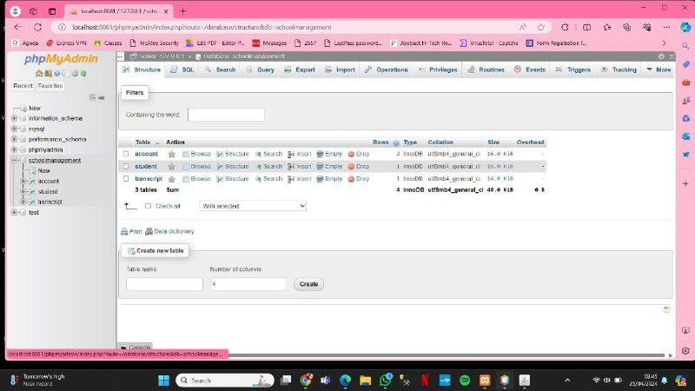

**Database**



**Tabel**

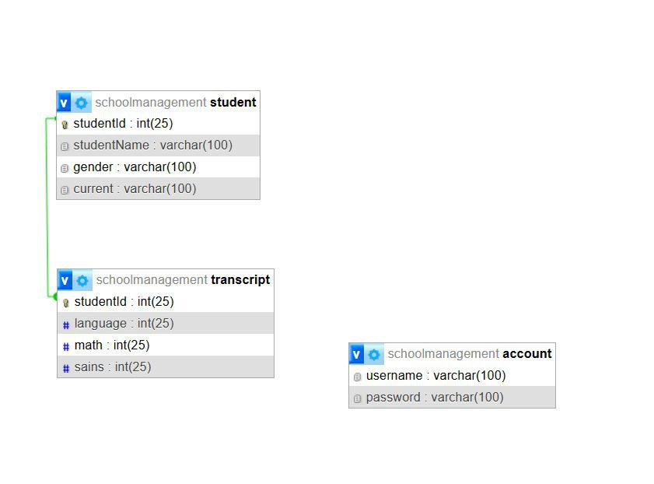

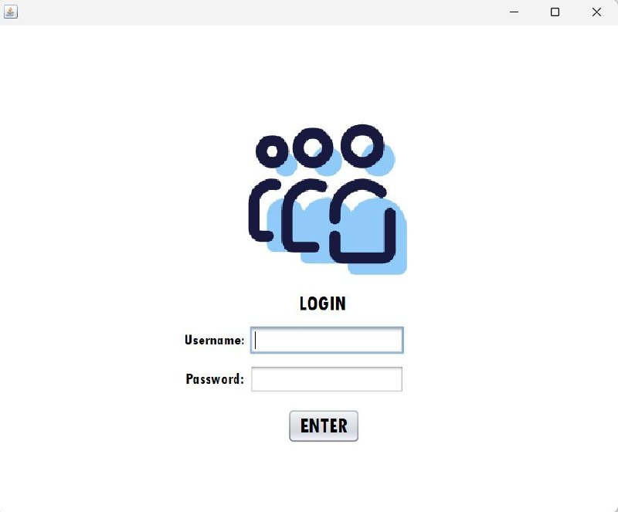

**Login**

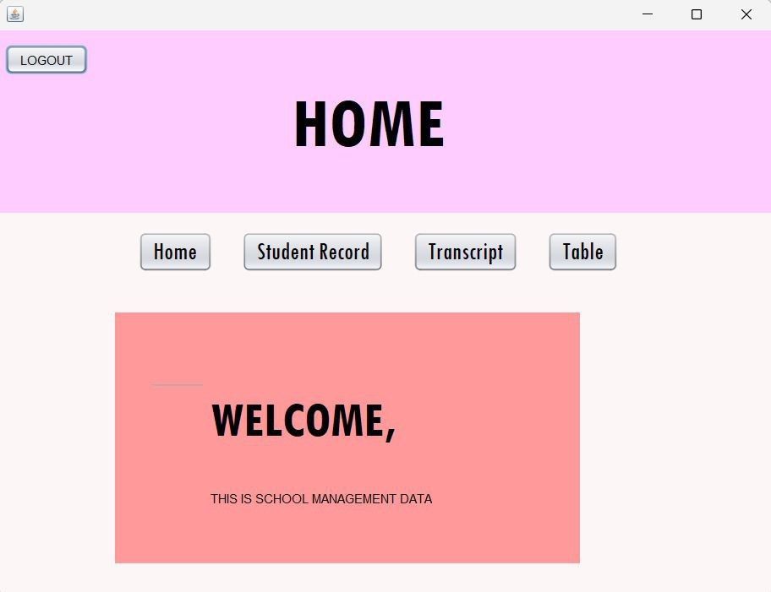

**Home Page**

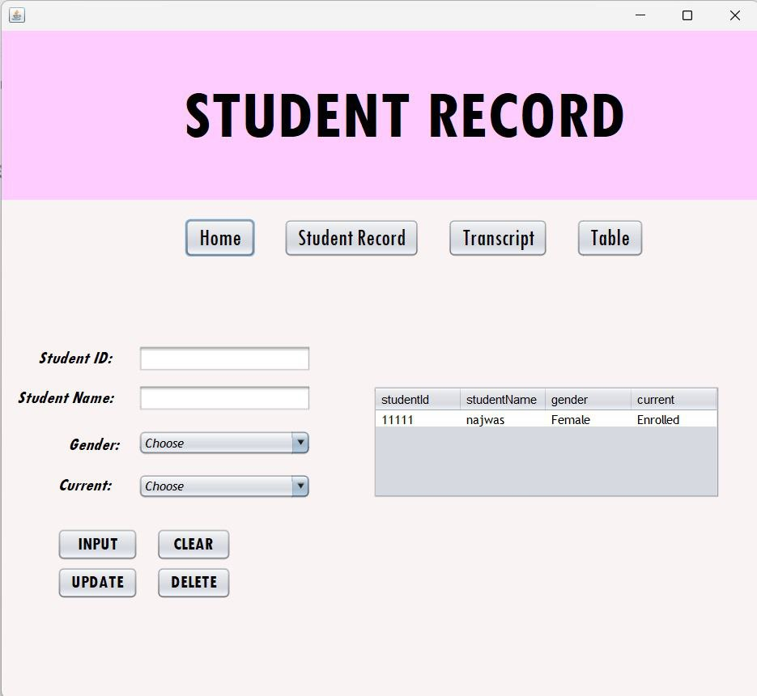

**Student Record**

**OUTPUT**

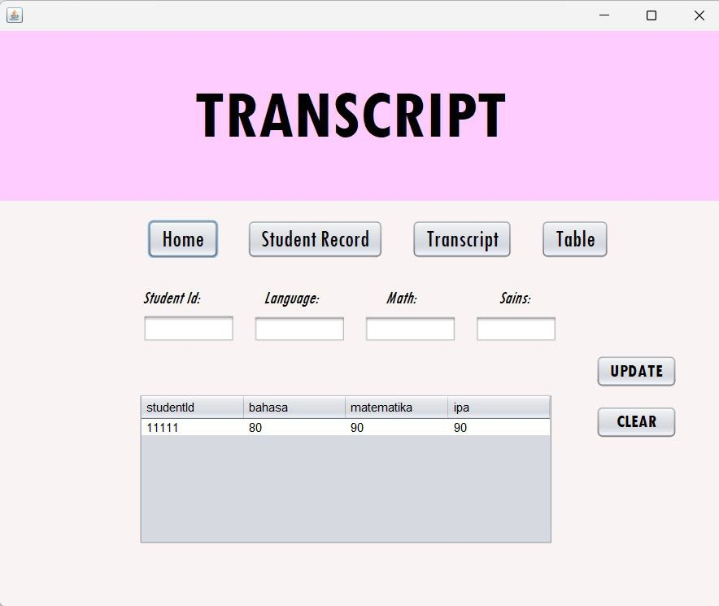

**Transcript Page**

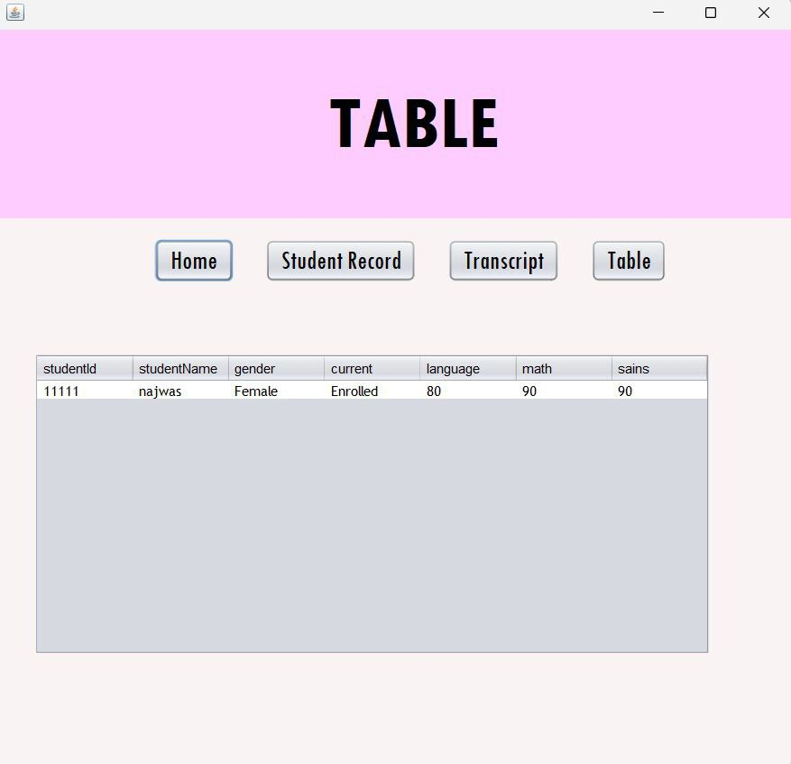

**Table Page**

**OUTPUT**

**CONFIGURATION**

Hardware : Hp, Acer

Operating System : Windows 10

Software : Apache Netbeans, XAMPP, Pichon, Microsoft Power Point, Microsoft Word